

Rapid Evaluation of Mid & South Essex ICS Virtual Hospital

www.midandsouthessex.ics.nhs.uk
Final Report V3
August 2022
Contents
1. Executive Summary 2
1.1 Background 2
1.2 Aim 2
1.3 Evaluation Team 3
1.4 Evaluation Approach 4
1.5 Key Findings 4
1.6 Conclusion 5

2. Public Summary 6

3. Policy and Evaluation Background 9
3.1 MSE ICS Logic Model

4. Description of Mid & South Essex Integrated Care System Virtual Hospital 10
4.1 Definition 10
4.2 Description of the Virtual Hospital 10
4.3 Extent of technology enablement 12
4.4 Problem to be solved 14
4.5 Organisations Involved 15

5. Evaluation Overview and Approach 16
5.1 Research Methodology 16
5.2 Evaluation Resources 16

6. Findings 17

7. Limitations 24
7.1 Key challenges 24
7.2 Plans for future evaluation 25

8. Conclusions 25

9. Recommendations 26

10. Appendices 28

1. Executive Summary
1.1 Background
In January 2022 MSE ICS established two new virtual wards within the Virtual Hospital model (Respiratory and Frailty Virtual Wards) and successfully secured a place in the NHS England ‘Virtual Wards Rapid Local Service Evaluation’ programme.
The virtual wards for respiratory and frailty patients were set up rapidly over a two-week period to respond to significant pressures on acute services during December 2022. The wards support both step up and step-down care pathways.
Remote monitoring equipment was purchased from Solcolm (Whzan Blue Box), and a larger SIM card was also purchased for each device to support remote consultations for patients that do not have access to a smart device. The Blue Box includes blood pressure monitor, pulse oximeter, and thermometer as standard and in addition to this digital scales, ECG devices and other key equipment has been included to further support the remote recording of vital signs. These observations are automatically shared to the clinical team by dedicated patient caseloads. To support system-wide cover for the virtual wards the caseload information can be accessed where necessary by the covering provider and this has support cover for annual leave, maternity leave, and sick leave in the event that one of the providers starts to experience capacity issues.
The MSE ICS Evaluation Team was established and leads identified as Stephanie Dawe, Senior Responsible Officer and Dr Ronan Fenton, Medical Director and Executive Lead for Virtual Hospital.
Initial diagnostic support was provided by NHS England through the Deloitte consultancy team, providing initial findings in relation to staff and patient feedback on the existing virtual wards and the benefits / barriers of the technology currently being utilised.
NHS England commenced a series of Virtual Ward Community of Practice events to share lessons learned and identify areas of best practice.
In April 2022, MSE ICS commissioned Newton Europe to support further investigations into the benefits of the virtual hospital model in place and identify areas for greater opportunity for the population we serve.
In May 2022, the system-wide Virtual Hospital Programme Board agreed a set of principles in line with the new quintuple aim, to shape the virtual hospital diagnostic and the Rapid Evaluation commenced in full. A performance dashboard was developed to respond to national and local monitoring requirements.
1.2 Aim
This rapid evaluation aims to provide an early assessment of the performance and outcomes of the Mid and South Essex Integrated Care System (MSE ICS) Virtual Hospital, providing early sight of operational issues, and assisting the system to take action to continue to build and improve upon this model of care.
The evaluation explores a series of questions agreed with NHS England as part of this evaluation:
- Are we maximising our virtual ward capacity so that we can accept as many referrals as possible?
- Are we referring all patients who are suitable for treatment in a virtual ward? If not, why not?
- Who has accessed the Virtual Hospital?
- What is the impact of our Virtual Hospital?
- How have we resourced the Virtua Hospital?
- How has technology been used to support delivery?
- Are we delivering great outcomes that improve the health and well-being of our patients?
  - Are we maximising independence?
  - Are we minimising infection and preventing functional decline?
  - Are we minimising readmissions?
- What factors have influenced the virtual ward (barriers and enablers)
- What learning can we share with colleagues across the NHS?
To respond to the questions posed as part of this evaluation the Deloitte Team supported an ethnographic research approach, shadowing 36 staff members and seeking patient feedback whilst observing 16 home visits to patients on the virtual wards.
The initial findings provided by the ethnographic research highlighted the benefits from ensuring that patient and staff feedback was key to this evaluation process.
In April 2022, Newton Europe was commissioned to undertake:
- A series of engagement meetings held across the system (May to June 2022)
- Inpatient studies across all acute providers (May 2022)
- Virtual Ward studies and deep dives undertaken, interviewing staff across all providers (May 2022)
- Check and challenge sessions held to review evaluation findings with key staff across the system (June 2022)
- Feedback sessions for frontline staff held (July 2022)
- Findings collated and final outcomes report developed (see Appendix 1).

1.3 Evaluation Team
The core members of the evaluation team and point of contact for MSE ICS in relation to the Virtual Hospital are:
Stephanie Dawe, Chief Executive Officer, Provide Health Community Collaborative
Stephanie.dawe1@nhs.net

James Wilson, Community Collaborative Transformation Director
James.wilson14@nhs.net

Michelle Angell, Portfolio Director, Mid and South Essex Partners, MSE ICS
m.angell@nhs.net

Acknowledgements
This evaluation was conducted in the main by Newton Europe for Mid and South Essex Integrated Care System on behalf of NHS England. This evaluation would not have been possible without the scale of input from staff across our system and special thanks goes out to them for their hard work and dedication to continue to transform our health and social care service to improve outcomes for the population we serve.

1.4 Evaluation Approach

A mixed-methods approach was used to conduct this evaluation using a range of quantitative data provided by our care providers, as well as several qualitative interviews with staff and patients supported by the virtual hospital.

To respond to the questions posed as part of this evaluation ethnographic research approach was undertaken, shadowing staff members and seeking patient feedback whilst observing home visits to patients on the virtual wards.

A series of engagement meetings were held across the system, alongside in-patient studies across all acute providers.

Check and challenge sessions were held to review evaluation findings with key staff across the system.

Feedback sessions were held for frontline staff and lessons learnt shared.

Findings were then collated and final outcomes report developed and shared with other health and cares systems from NHS Futures Platform, NHSE Community of Practice Forums and direct meetings with interested parties. Visits being arranged for ICSs to see MSE ICS virtual wards in action.

1.5 Key Findings

Key findings relating to the agreed evaluation questions are outlined below:

Are we maximising our virtual ward capacity so that we can accept as many referrals as possible?
- A total number of 1,258 patients have been supported on the virtual wards since April to June 2022.
- There are opportunities to increase virtual ward capacity by 65% without the need for any further investment.

Are we referring all patients who are suitable for treatment in a virtual ward? If not, why not?
- There is opportunity to increase total referrals by 173% by building knowledge and confidence referrers.

Who has accessed the Virtual Hospital?
- There are a greater number of female patients placed on the virtual ward. Admissions through virtual wards reflect the MSE Population, however, females are disproportionately high in both Frailty and Hospital at Home. 84% of admissions to the respiratory virtual wards were for patients over 75. Females in MSE live longer than males, hence why a larger proportion of female patients in a service with an older mean age is expected. Hospital at Home has a broader range of ages and disproportionately more females within this service.
- The majority of patients placed onto the virtual wards are white and aged 75+. Overall, just 19% of the MSE population is over the age of 65. A higher proportion of which are female.
- However, within virtual wards a disproportionately larger % of patients are over the age of 65. This is also seen in acute admissions and attendances in MSEFT.
- Services are aimed at conditions which correlate with age in many cases, such as Frailty.

What is the impact of our Virtual Hospital?
- Number of acute bed days saved as of July 2022 equates to 1,4163 (this does not include UCRT and Hospital@Home for April where the data is not available)
- Cost savings to date for the two new virtual wards established in January 2022 equate to £1,333,480. The average saving per month for respiratory is £100,347 and £230,202 for frailty.
- The average length of stay is 12 days (Respiratory virtual ward), 16 days (Frailty Virtual Ward) and 35 days (Hospital@Home).
- The majority of patients are discharged to their usual residence (72.7%) as opposed to care homes at 3.6%.
How have we resourced the Virtua Hospital?
- The full number of staff required to operate the 60 bedded Frailty Virtual Ward across MSE is 122.4 WTEs. This has been resourced with 36.06 WTE members of existing staff, where services have been aligned to the virtual hospital model and 86.31 WTE of new staff.
- The Respiratory Virtual Ward requires 29.5 WTEs of which all are new appointments.
- A detailed breakdown of the staffing for the Frailty and Respiratory Virtual Wards is attached in Appendix 2.

How has technology been used to support delivery?
- Existing technology being utilised on the virtual wards is based on patient need upon clinical assessment and does not replace the need for clinical review and intervention. Following review of the findings further action will be taken to ensure that any barriers being faced in using this equipment are addressed.

Are we delivering great outcomes that improve the health and well-being of our patients?
Are we maximising independence?
- 23% of patients treated in a virtual ward achieved a more independent social care outcome

Are we minimising infection and preventing functional decline?
- Patients are up to five times less likely to acquire an infection when treated on a virtual ward compared to an acute setting.
Are we minimising readmissions?
- Up to 2.5 times fewer patients treated on a virtual ward are readmitted to frailty beds than the national benchmark.

What factors have influenced the virtual ward (barriers and enablers)
- Barriers – lack of staff knowledge or confidence in virtual wards, lack of social care capacity, lack of capacity in virtual ward, patient and family wishes, lack of capacity within community health service, equipment availability and home conditions unsuitable for discharge.
- Enablers – supporting data, tools and technology, performance visibility and governance, clinical leadership, aligned pathways, practice and process and capability of staff.

1.6 Conclusion

The existing technology enabled virtual wards in MSE to deliver improved outcomes compared to traditional pathways, strengthening the case to improve utilisation

- We can improve utilisation by up to 65% through operational improvements over the next 12-18 months, delivering improved outcomes for over 1,350 people per year

- This will require a joined-up end-end transformation programme that includes
  - Improved referral rates – with opportunity to increase total referrals by 173% by building knowledge and confidence of referrers
  - Capacity improvements – with an opportunity to increase capacity by 65% by focusing on discharge delays, staff scheduling and ways of working
  - Consideration of key enablers – including culture, supporting data, tools & technology, performance visibility & governance, clinical leadership, aligned pathways, practice and process, and capability of key staff

- Utilisation could be further increased through a systematic approach to evaluation and commissioning that enables:
  - Increased capacity for current virtual wards that are still capacity constrained following delivery of operational improvement
  - Expanded capability of the current virtual wards to allow more patients to be treated
  - Commissioning new virtual wards to allow additional patient cohorts to be treated

- Further information needs to be obtained on a larger control group and over a longer period, to fully understand the impact of the virtual hospital model.

2. Public Summary
In response to the increasing demands on our health and care system across mid and south Essex and the national ambition to increase bed numbers through the utilisation of virtual wards, Mid and South Essex Integrated Care System (MSE ICS) has established two new virtual wards, providing four virtual wards for each hospital site in total.

The community Respiratory and Frailty Virtual Wards started to receive patients from January 2022 and work alongside the Urgent Community Response Team and our hospital led Hospital@Home service, providing 207 virtual ward beds across mid and south Essex in total.
Following clinical assessment where deemed appropriate the patient is provided with specialist telehealth technology that monitors basic observations and feeds these back to the virtual ward team.
MSE ICS was successful in an application to participate in a rapid evaluation of the virtual wards we currently have in place and the outcomes of this evaluation outline a number of significant benefits for our population through the introduction of this model. The rapid evaluation included staff and patient feedback in respect of experience and barriers to access / utilisation of technology. The key findings are noted below for information:
Are we maximising our virtual ward capacity so that we can accept as many referrals as possible?
- A total number of 1,258 patients have been supported on the virtual wards since April to June 2022.
- There are opportunities to increase virtual ward capacity by 65% without the need for any further investment.

Are we referring all patients who are suitable for treatment in a virtual ward? If not, why not?
- There is opportunity to increase total referrals by 173% by building knowledge and confidence referrers.

Who has accessed the Virtual Hospital?
- There are a greater number of female patients placed on the virtual ward. Admissions through virtual wards reflect the MSE Population, however, females are disproportionately high in both Frailty and Hospital at Home. 84% of admissions to the respiratory virtual wards were for patients over 75. Females in MSE live longer than males, hence why a larger proportion of female patients in a service with an older mean age is expected. Hospital at Home has a broader range of ages and disproportionately more females within this service.
- The majority of patients placed onto the virtual wards are white and aged 75+. Overall, just 19% of the MSE population is over the age of 65. A higher proportion of which are female.
- However, within virtual wards a disproportionately larger % of patients are over the age of 65. This is also seen in acute admissions and attendances in MSEFT.
Services are aimed at conditions which correlate with age in many cases, such as Frailty.

What is the impact of our Virtual Hospital?
- Number of acute bed days saved as of July 2022 equates to 1,4163 (this does not include UCRT and Hospital@Home for April where the data is not available)
- Cost savings to date for the two new virtual wards established in January 2022 equate to £1,333,480. The average saving per month for respiratory is £100,347 and £230,202 for frailty.
- The average length of stay is 12 days (Respiratory virtual ward), 16 days (Frailty Virtual Ward) and 35 days (Hospital@Home).
- The majority of patients are discharged to their usual residence (72.7%) as opposed to care homes at 3.6%.
How have we resourced the Virtua Hospital?
- The full number of staff required to operate the 60 bedded Frailty Virtual Ward across MSE is 122.4 WTEs. This has been resourced with 36.06 WTE members of existing staff, where services have been aligned to the virtual hospital model and 86.31 WTE of new staff.
- The Respiratory Virtual Ward requires 29.5 WTEs of which all are new appointments.
- A detailed breakdown of the staffing for the Frailty and Respiratory Virtual Wards is attached in Appendix 2.

How has technology been used to support delivery?
- Existing technology being utilised on the virtual wards is based on patient need upon clinical assessment and does not replace the need for clinical review and intervention. Following review of the findings further action will be taken to ensure that any barriers being faced in using this equipment are addressed.

Are we delivering great outcomes that improve the health and well-being of our patients?
Are we maximising independence?
- 23% of patients treated in a virtual ward achieved a more independent social care outcome

Are we minimising infection and preventing functional decline?
- Patients are up to five times less likely to acquire an infection when treated on a virtual ward compared to an acute setting.
Are we minimising readmissions?
- Up to 2.5 times fewer patients treated on a virtual ward are readmitted to frailty beds than the national benchmark.

What factors have influenced the virtual ward (barriers and enablers)
- Barriers – lack of staff knowledge or confidence in virtual wards, lack of social care capacity, lack of capacity in virtual ward, patient and family wishes, lack of capacity within community health service, equipment availability and home conditions unsuitable for discharge.
- Enablers – supporting data, tools and technology, performance visibility and governance, clinical leadership, aligned pathways, practice and process and capability of staff.

3. Policy and Evaluation Background
In April 2022 NHS England began working with ten existing virtual ward providers on rapid local evaluations to understand virtual ward models and share implementation experiences to benefit ICSs and providers who are at an earlier stage.

Enablers for success: virtual wards including hospital at home development. In the longer-term, NHSE has plans in place to work with the National Institute for Health and Care Research as part of a national evaluation of virtual ward provision.

Whilst the focus of this rapid local service evaluation was on acute bed usage, workforce and technology enablement, the review has been extended to consider other outcomes of interest.

3.1 Mid and South Essex Logic Model
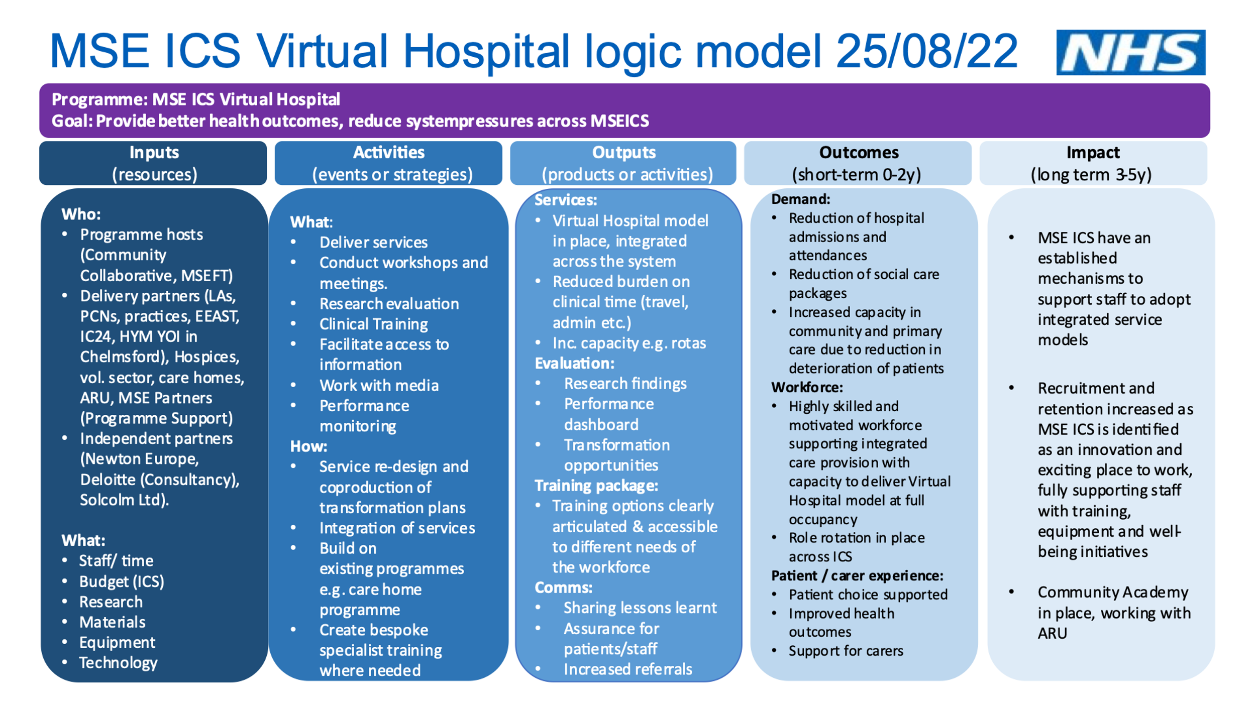
4. Description of the MSE ICS Virtual Hospital
4.1 Definition
The MSE ICS Virtual Hospital model is aligned to the national definition relating to virtual wards and Hospital@Home models of care.
Virtual ward
A virtual ward is a safe and efficient alternative to NHS bedded care that is enabled by technology.

Virtual wards support patients who would otherwise be in hospital to receive the acute care, monitoring and treatment they need in their own home.

This includes either preventing avoidable admissions into hospital or supporting early discharge out of hospital.

4.2 Description of the Virtual Hospital
As outlined in the following diagram the MSE ICS Virtual Hospital consists of four component parts and supports both step up admission avoidance and step-down early discharge services across MSE.

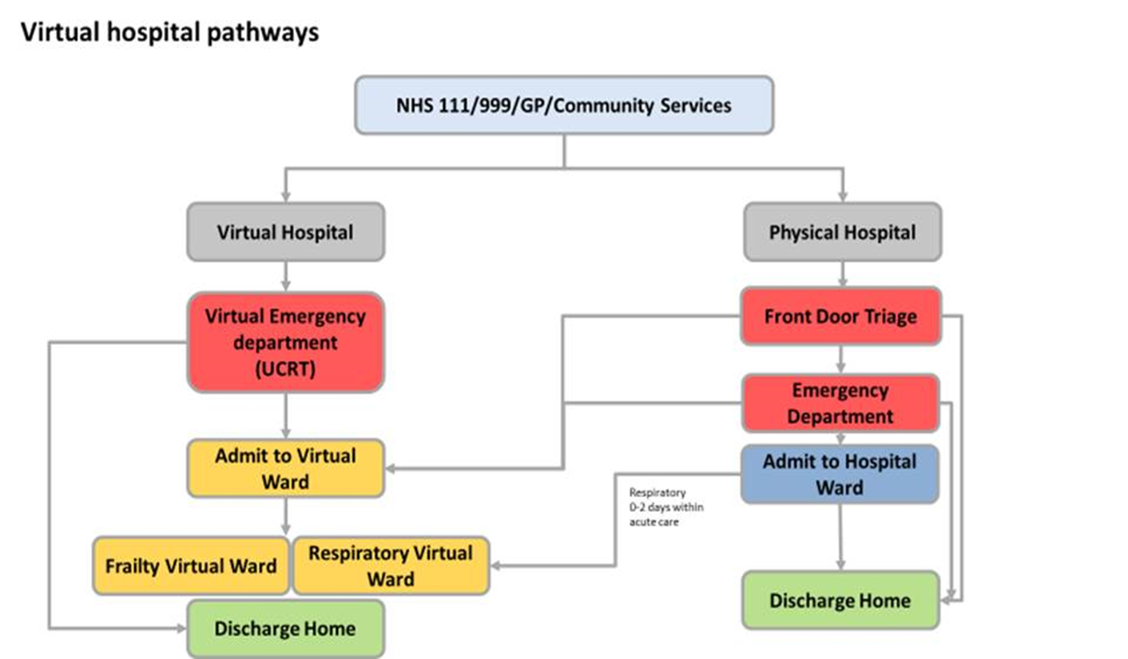

Details of each of the virtual wards are outlined below:

1) Community Led Virtual Emergency Department (existing virtual ward supports 42 virtual ward beds commenced in April 2020)
Referrals accepted 08:00 – 22:00 seven days a week and Hours of Operation 24-hour service and patient contacted / seen within two hours. Referrals received from EEAST, primary care, community and acute (Step-up and Step-down)

This is provided by the Urgent Community Response Team (UCRT) at the point of entry for patients. Any patients deemed by UCRT to be requiring a longer period of more complex clinical virtual support and monitoring in their usual place of residence (for any period up to 14 days), will be admitted where necessary to one of six Virtual wards operating across MSE.

2) Community Led Frailty Virtual Wards (commenced 10th January 2022)
Referrals accepted 09:00 – 14:00 Monday to Friday and Hours of Operation 09:00-17:00 Monday to Friday and 09:00 to 15:00 Saturday / Sunday (EPUT / NELFT and Provide) Out of Hours Community Respiratory on Call/ Consultant on Call). Referrals received from Acute (ED, inpatient wards including short stay (such as CDU, SDEC, AMY, SAU and acute frailty wards) and community UCRT (Step-up and Step-down)

This consists of three Virtual Frailty Wards, each serving local geographies with in MSE (SWE, SEE and Mid Essex) - holding a potential capacity of up to 20 adult patients with frailty/complex co-morbidities each per ward.

- The patient is supported in their own home, with appropriate clinical and therapy support and intervention. Clinical, social and therapy needs would be determined and arranged for each individual patient with their input where the patient has capacity to do so.
- A multidisciplinary team is in place specifically tailored to provide rehabilitation support in patients homes. The skill mix of the team incorporates Physiotherapists, Occupational Therapists, Rehabilitation assistants and Registered Nursing staff.
3) Community Led Respiratory Virtual Ward (commenced 10th January 2022)
Referrals accepted and Hours of operation 08:00 – 14:00 seven days a week (EPUT and NELFT). Referrals received from Acute (recommendation of a consultant / hospital respiratory nurse and ED) and community UCRT (Step-up and Step-down)

This consists of four Virtual Respiratory Wards each serving local geographies with in MSE (SWE, SEE and Mid Essex)- holding a potential capacity of up to 15 adult patients with respiratory needs. The respiratory virtual ward costs are included in a separate business case relating to the Breathlessness and Diagnostic Service as the staffing model is intrinsically linked to that service.

- The patient is supported in their own home, with appropriate clinical and therapy support and intervention.
- Clinical, social and therapy needs would be determined and arranged for each individual patient with their input where the patient has capacity to do so.

NB: Community Led Heart Failure Virtual Ward (pilot due to commence Autumn 2022)
Hours of Operation to be defined through pilot. Referrals received from Acute (recommendation of a consultant / hospital Heart Failure nurse and ED) and community UCRT

- MSE ICS has commenced the scoping phase to implement a Heart Failure virtual ward which would provide 15 virtual ward beds across MSE and is currently being prepared for go live.

4. Hospital@Home (commenced in 2016)
Referrals accepted and Hours of operation 07:00 – 22:00 seven days a week. Referrals received from Acute Step-down
Mid and South Essex NHS University Foundation Trust have established a hospital-at-home service to provide skilled, multidisciplinary care to support earlier discharges for patients where this is appropriate. There are currently 45 virtual ward beds provided by the Hospital@Home service across Mid and South Essex.

- Hospital at home provides continuing medical management under the care of a hospital consultant but in the patient’s home. The service is provided by nurses in the patient’s home, administering IV’s, wound care, oxygen weaning, observation monitoring and blood monitoring, supported by microbiology and the recent introduction of neutralising monoclonal antibody treatment.
- The MSE HCP ICS Hospital@Home team have recently started to pilot an Acute Kidney Injury pathway.
- Once patients are medically fit, they are discharged back to the care of their GP or community teams.

4.3 Extent of technology enablement
The Respiratory and Frailty Virtual Wards both utilise Whzan telehealth technology procured from Solcolm Ltd to support remote monitoring of basic observations, and this is due to be extended to the Heart Failure Virtual Ward. This technology is utilised to a greater extent on the Respiratory Virtual Ward.

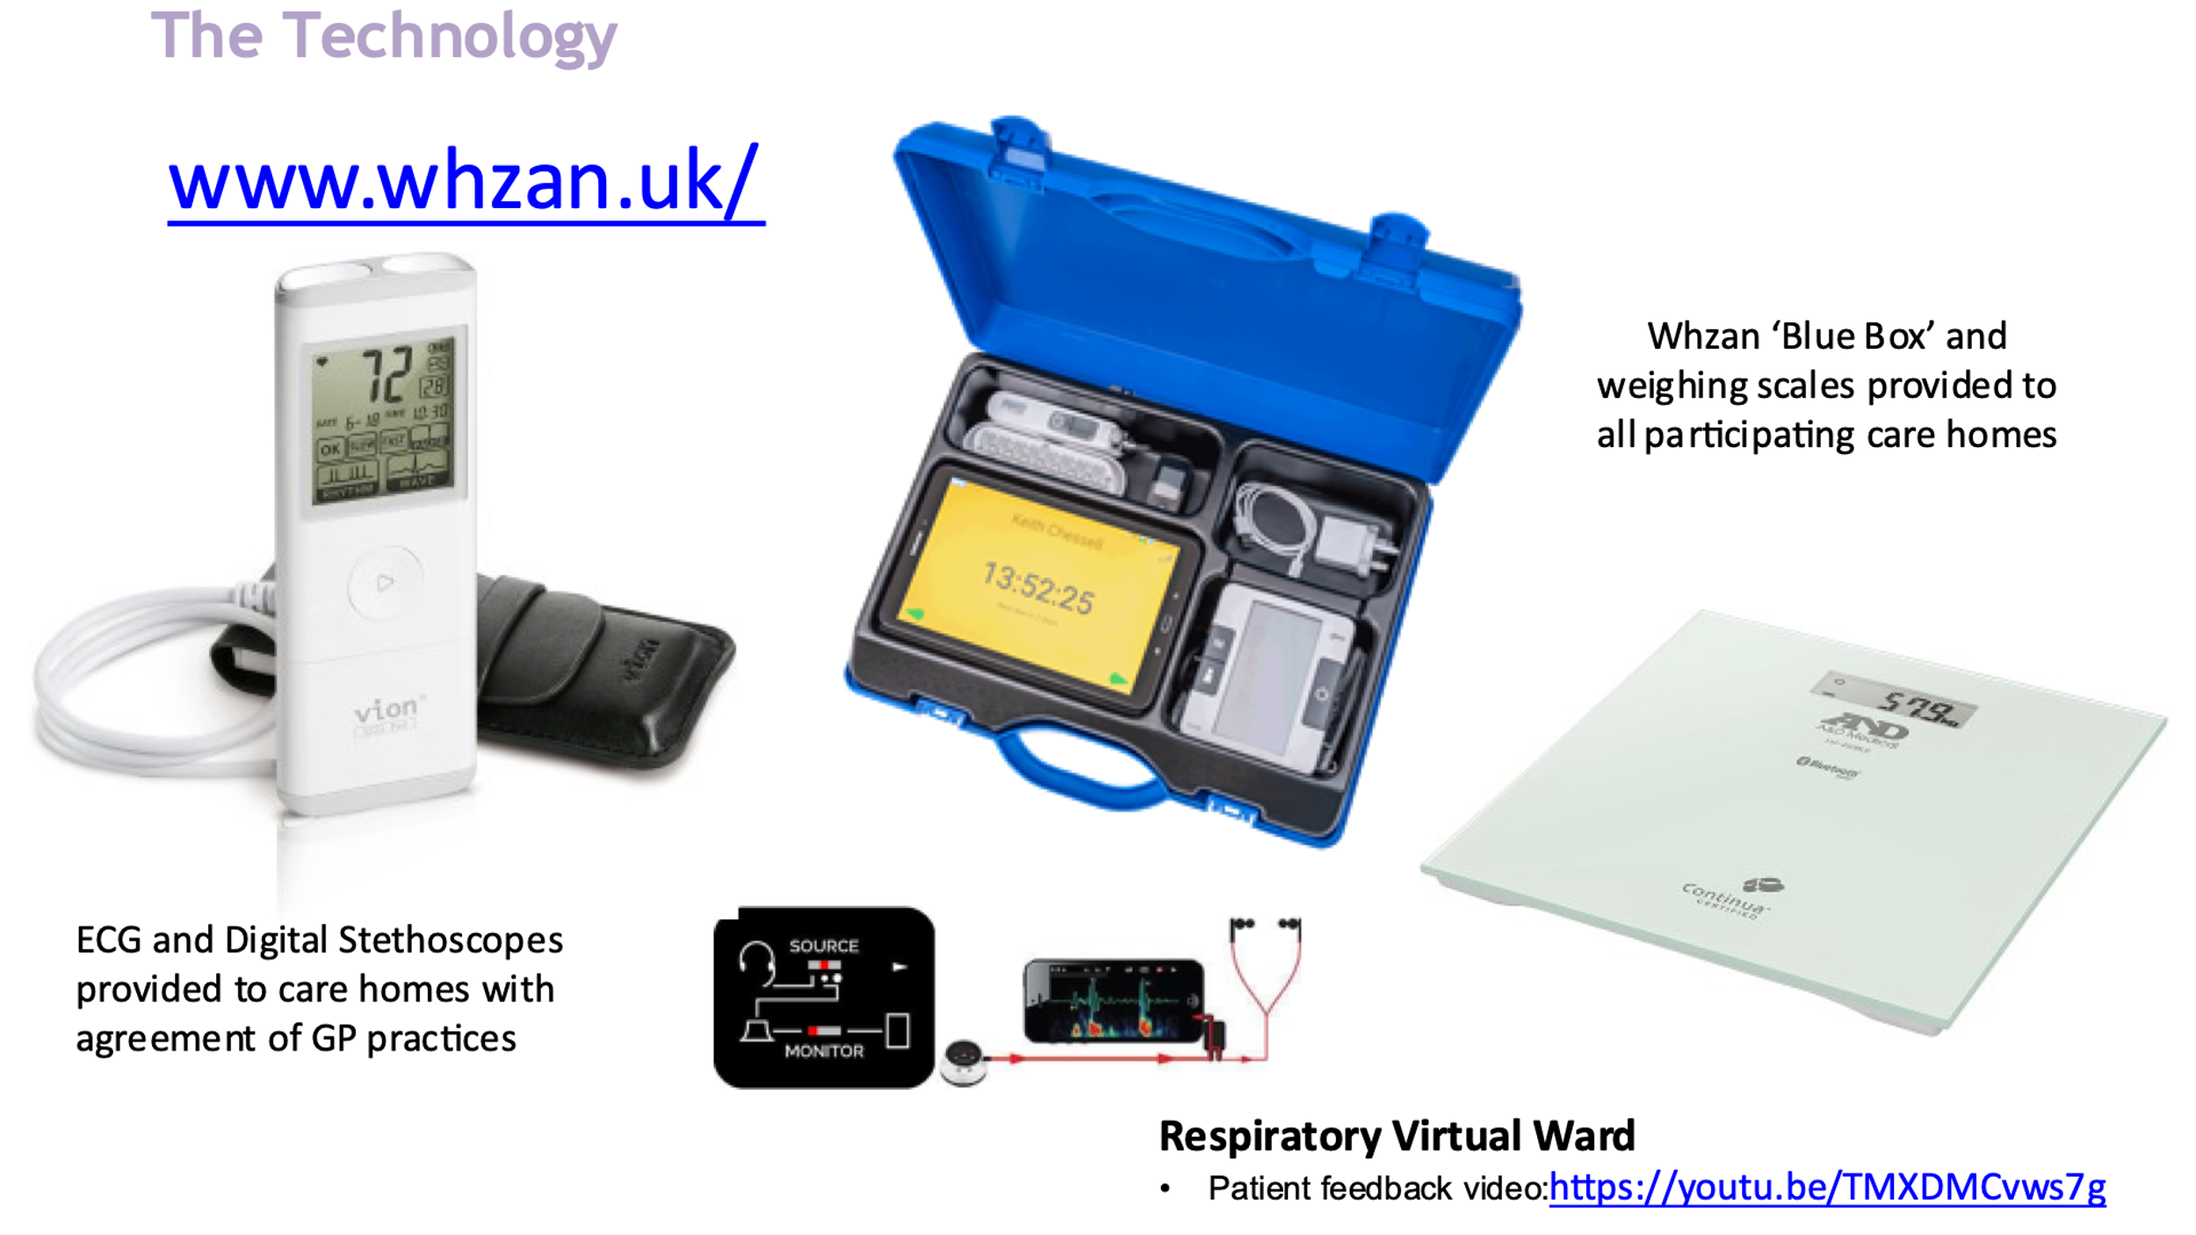
Full Equipment List:
- Whzan telehealth monitoring equipment (Supplier Solcolm Ltd https://www.solcom.com ) – pulse oximeter, BP monitor and thermometer (including weighing scales where appropriate)
- SIM cards within the Whzan tablet to support remote consultation
- 12 lead ECG devices and 6 lead Alivecor ECG devices
- Standard pulse oximeter where above not required to monitor
- Oxygen ISTATs
- Higher specification stethoscopes / digital stethoscopes

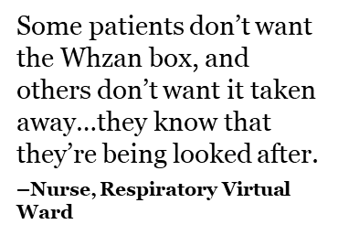
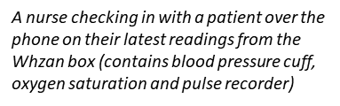

The rapid evaluation considered the experience of both staff and patients utilising the Whzan technology to support the virtual wards.

Key findings and implications

Navigating ambivalence

- Getting patients to adopt remote monitoring technologies involves more than just transferring these devices from the hospital to the home. It requires re-assigning complex networks of knowledge, skills, humans and technologies to places and situations that are connected to the characteristics of the disease itself and the patient’s own life trajectory and emotional needs.

- Patients are often deeply ambivalent about the benefits and pitfalls of technology, at once sites of reassurance and anxiety

Relational technology
- Whilst these technologies are at times central in boosting patents’ autonomy and enabling them to participate more proactively in their care and disease-management, many were also partially or fully dependent on others (e.g., family members) to get them to work.

- Introducing these devices into patients’ homes sparks a series of shifting relationships within and among a network of technologies, lay people and healthcare professionals.

Context remains key
- These devices are not substitutes but instruments of care, requiring constant interpretation from nurses who use their deep understanding of their patients’ context to make sense of their numbers and manage risk accordingly.

- Some patients may withhold information or deliberately make themselves sound better or worse over the phone, depending on whether they want to be left alone or attempt to secure a social visit by the nurses out of sheer loneliness.

Opportunity areas

Technology cannot replace human care
- There is a need to constantly identify and map the relational context of remote monitoring technology provision over time within the changing lives and needs of patients and their caregivers to ensure that they are always augmenting, rather than replacing core therapeutic relationships.

Design Inclusively
- Patients with visual impairments and literacy issues will struggle to use Whzan boxes as they are currently implemented. Designers and service providers should work with caregivers and excluded people, including charities representing these groups, to co-create suitable technological interventions.

4.4 Problem to be solved
Why Virtual Wards?
- Health and social care system under increasing pressure due to unprecedented demands as a result of Covid-19
- Hospitalised patients are 61 times more likely to develop disability in Activities of Daily Living than those not hospitalised.
- 17% of older medical patients who were walking independently 2 weeks
prior to admission needed help to walk on discharge
- 50% of patients experience functional decline between admission and discharge
- Deconditioning contributed to delayed discharge in more than 47% of older
patients
- Once discharged, only 39% of those with a new or additional ADL disability were back to their usual level of function after one year

Context
- NHSE recommending 40-50 virtual ward beds per 100k population (460-600 for MSE)
- Currently ≈ 207 virtual ward beds across the three ward types (Hospital @ Home, Respiratory, Frailty and UCRT), with heart failure upcoming.

Challenges
- Utilisation has improved, but there are further opportunities to improve as still <60% (<115/270)
- An optimised setup could be worth >£8m p.a. to the system
- Some misunderstanding and reported dissatisfaction, which is limiting referrals and could prevent further virtual ward development
- Differentiation between virtual ward and rehab
- pathways, and their respective capacity requirements
- No single point of truth, with variable and manual data reporting coming from a range of sources

Requirement
- Ultimately, we know we have an exciting foundation in place, and that there are challenges and opportunities to improve.
- After rapidly mobilising, we now need to step back and form a systematic development programme and strategy that aligns stakeholders, drives transparency, and maximises impact for both patients and the system.

- The rapid evaluation process has provided MSE ICS with an agreed set of principles for success and to build an evidence base of our current performance and identify further opportunities.

4.5 Organisations involved
The MSE ICS Virtual Hospital is an integrated system response to the demands faced by all health and social care partners across the system. There is still significant work to be undertaken to further transform these services and gain the maximum benefits identified for our local population and clinical workforce.
To date the main organisations involved in supporting the Virtual Hospital model across MSE have been:
- Integrated Care Board
- Community Provider Organisations: Community Collaborative – Essex Partnership University NHS Foundation Trust, North East London NHS Foundation Trust and Provide CIC
- Secondary Care Provider Organisation: Mid and South Essex NHS Foundation Trust – Basildon, Broomfield and Southend Hospital sites.
- Primary Care: Practice and Primary Care Network response.
- Local Authority and Social Care: Essex County council, Southend City Council and Thurrock Council.
- Hospices
- Out of hours providers: IC24, NHS 111
- Emergency Response: East of England Ambulance Trust
- Solcom Ltd – supplier of telehealth technology
- Care Homes
- Her Majesty’s Prison and Youth Offenders (HMP YOI) Institute located in Chelmsford
As we continue to develop these services there is a need to further integrate our services across the system to address recruitment and retention issues, ensure maximum support and patient choice of care, to be delivered within their own home and reduction on duplication of resources that will result in cost savings for the system that can be repurposed to continue to drive our transformation agenda.
Work is taking place with Anglia Ruskin University to develop a Community Academy across the ICS, working together to ensure that our health care professionals are supported with role rotation and career opportunities to ensure that MSE ICS remains an attractive and exciting place for staff to work.
There is a dedicated resource overseeing the way in which the voluntary sector can support this model of care and review the support provided to carers in their own homes and within care homes to ensure that people can remain within their preferred place of care.
Since the establishment of the Virtual Hospital one patient has been admitted onto the respiratory virtual ward from HMP YOI Chelmsford. As a result, a number of barriers needed to be overcome to provide remote care to this individual and there is a need to consider how we ensure equity of access to care services for this cohort of patients.

5. Evaluation Overview and Approach
5.1 Research Methodology
A mixed-methods approach was used to conduct this evaluation using a range of quantitative data provided by our care providers, as well as a number of qualitative interviews with staff and patients supported by the virtual hospital.
To respond to the questions posed as part of this evaluation the Deloitte Team supported an ethnographic research approach, shadowing 36 staff members and seeking patient feedback whilst observing 16 home visits to patients on the virtual wards.
The initial findings provided by the ethnographic research highlighted the benefits from ensuring that patient and staff feedback was key to this evaluation process.
In April 2022, Newton Europe was commissioned to undertake:
- A series of engagement meetings held across the system (May to June 2022)
- Inpatient studies across all acute providers (May 2022)
- Virtual Ward studies and deep dives undertaken, interviewing staff across all providers (May 2022)
- Check and challenge sessions held to review evaluation findings with key staff across the system (June 2022)
- Feedback sessions for frontline staff held (July 2022)
- Findings collated and final outcomes report developed (see Appendix 1).

Table one in section six below outlines provides a detailed summary of the research methodology applied by Newton Europe to support the rapid evaluation process and the findings from that research.

5.2 Evaluation Resource
The MSE ICS rapid evaluation benefitted from specialist support provided by Deloitte and Newton Europe.
The evaluation tools utilised in the main were interviews and observations held to obtain insight into how the service currently functions and the experience from a patient and staff viewpoint but also reviewed and considered data from community, acute and primary care providers to review performance across the system and identify areas of opportunity.

6. Findings

The MSE ICS Virtual Hospital model has benefited from having pre-existing wards in respect of UCRT and Hospital@Home and several historic early discharge schemes. The lessons learnt from these services supported the system to establish the two new virtual wards at pace over the course of two weeks during December 2021. Data was collected from April 2022, to monitor service provision and a fortnightly snapshot dashboard has been developed for review on an ongoing basis by the Virtual Hospital Programme Board. The data is being collated through Systmone by each community provider and reported back alongside the acute data to a central point in the Community Collaborative to feed into the dashboard (See Appendix 3).

The full outcomes pack developed by Newton Europe is attached at Appendix 1 and the research methodology and key findings are noted below:
Table 1.
Focus Question | Methodology & Data Source | Insight
Are we maximising our virtual ward capacity so that we can accept as many referrals as possible? | A point of prevalence study considered 96 patients currently on Frailty, Hospital @ Home and Respiratory Virtual Wards.  MDT teams were asked “Should this person be spending the night on the virtual ward, and are they planning to actually spend the night on the virtual ward?” | When broken down by type of virtual ward, the following figures can be seen:  Frailty: 63% needed a virtual ward, 37% could have been discharged  Respiratory: 62% needed a virtual ward, 38% could have been discharged  Hospital @ Home: 74% needed a virtual ward, 26% could have been discharged
 | A point of prevalence study considered 96 patients currently on Frailty, Hospital @ Home and Respiratory Virtual Wards. MDT teams were asked “Should this person be spending the night on the virtual ward, and are they planning to actually spend the night on the virtual ward?”  For each patient that should not have spent the night, but was going to stay overnight, the MDT was asked “What is the main reason for delay to discharge this patient from the virtual ward?” | ‘Waiting on Health Information’ was the biggest patient discharge delays, consisting of patients waiting on blood results to confirm discharge, waiting for a physio review, waiting for another appointment to be scheduled or waiting on another medical team to accept the patient. Social care capacity was also a major reason for delay, with 20% of delayed patients unable to leave the virtual ward until a care package was put in place. As we have discussed in the outcomes section, use of virtual wards can enable reduced social care which could free up extra capacity to support additional discharges.  By getting effective visibility of patient discharge delays on our virtual wards and addressing them through an effective “improvement cycle” governance process, it is expected that we could halve the average delay per patient.
- Barriers to increasing virtual ward capacity (clinical time) | Modelling 1 year of patient referral data over time and 4 weeks of staff rotas for the Hospital @ Home South East team. | On an average day there are 39 hours of nurse time in the roster.  Due to the variation in how the nurses’ shifts are spread across the week, some days have as few as 21 ½ hours scheduled, just 55% of an average day.  In a typical week, the least staffed day had 70% of the nursing hours scheduled compared to the average day.  For a service that delivers a consistent number of daily visits to its patients, we need a consistent number of staff. Variation from this leads to poorer patient outcomes, as illustrated on the following slide.
 | Modelling 1 year of patient referral data over time and 4 weeks of staff rotas for the Hospital @ Home South East team. | 74% of patients start their treatment with Hospital @ Home either on the same day, or the day after their assessment from the team.  Because there are 22% fewer nursing hours on shift at the weekends, the nursing time is spent entirely doing patient visits in the community. This means that there are fewer staff available to perform assessments of patients currently in acute hospital beds.  Because these assessments haven’t been performed over the weekend, there are patients that remain in acute beds unable to go home whilst the services ‘catches-up’ with these referrals at the start of the week.
 | Nurses from Frailty and Hospital @ Home teams were shadowed and their time was categorised as patient-facing, enabling or lost time. | Only 24% of nurse time was spent treating patients with most of their time spent on enabling activity.  Travel is the biggest category of non-patient facing time, responsible for 41% of time in total (driving and other travel).  Admin is also a significant contributor to non-patient facing time, responsible for 20% of time in total (writing notes, checking information). This involved noting down patient medication data and scheduled appointments, as well as writing down a summary of all actions performed during the visit.  One nurse described writing out the same information into the patient folder, her own notebook and system one as “incredibly frustrating” and “waste of time that could be spent fitting another patient visit in”.  These findings are consistent with those from the Population Health Management team, who have recently conducted similar studies with community nurses
 | Nurses from Frailty and Hospital @ Home teams were shadowed and their time was categorised as patient facing, enabling or lost time. Patient destinations were recorded, and the time spent traveling was measured, this was then compared to the optimal route using a travel optimisation tool. A like for like comparison was made for rush hour conditions. | Of the 36% of time spent driving, we could remove up to 10% through improved routing. Applying a 50% target would save 5% of total staff time.  Of the 12% of time spent writing notes, we could decrease it by half through removing duplication of work. Applying a 70% target would save 4% of non-patient facing time.  Addressing both of the above, it can be concluded that up to 9% of total nursing time could be freed up to spend more time treating patients.
Are we referring all patients who are suitable for treatment in a virtual ward? If not, why not?  - Barrier to referrals (lack of awareness and confidence in the virtual ward) | Virtual ward activity data was combined for NELFT, EPUT and Provide for the available period. Where good quality data existed, the referral source was determined. | 77% of historical referrals to the Virtual Hospital have come from Inpatients and UCRT. We have prioritised understanding of these referral routes to determine opportunities to increase referral rates.
 | A review of 302 inpatient beds with members of staff from the acute and virtual wards across Basildon, Broomfield and Southend hospitals was carried out. The specific roles of these people can be found in the appendix, “In an ideal world, would this person be in a virtual ward at midnight tonight?” | Overall, there is an opportunity to increase the number of referrals to virtual wards by over 6x. This varied across the three services, as detailed in the table.  The service with the largest potential increase in referral volume was identified as the Frailty Virtual Ward, which in an ideal world would see 10x the number of people come through the service. This service also provides the largest impact on reductions to ongoing care packages.  Hospital @ Home could receive up to 8x more referrals based on the inpatients assessed, and the Respiratory Virtual Ward could receive up to 4x more referrals.  To increase referrals, we must understand what the reasons are that referrals for suitable patients are being blocked.
 | A review of 302 inpatient beds with members of staff from the acute and virtual wards across Basildon, Broomfield and Southend hospitals was carried out. For each patient it was asked “In an ideal world, would this person be in a virtual ward at midnight tonight? If they should be, but won’t, what was the blocker to discharging this person to a virtual ward?” | 45% of missed referrals were due to inpatient staff not understanding when it was appropriate or having the confidence in the virtual ward to make a referral. 11% of these individuals would have also needed a social care package to enable discharge after referral.  Social care capacity is also a significant limiting factor for patients who had been lined up for a virtual ward discharge by inpatient staff, accounting for 28% of all missed referrals.  Given significant national and local challenges around access to social care packages it is proposed that initial improvement should target the knowledge and confidence gap.  There were also 4 examples of virtual ward capacity being a limiting factor – whilst this wasn’t a major driver of missed referrals, it reinforces the need to understand virtual ward capacity and patterns which is considered later in this deck.
- Barrier to referrals (lack of awareness and confidence in the virtual ward) | 32 patients who had been in contact with UCRT over the previous 2 days were reviewed to determine “In an ideal world, could this person have been referred to a virtual ward? If they should have been but weren’t, what was the blocker to discharging this person to a virtual ward?”. | Referrals from UCRT could increase by 63% if the UCRT knowledge gap alone could be addressed.  All of this opportunity is for referring people into the Frailty Virtual Ward – there were no cases in which we could have increased referrals to Respiratory Virtual Ward.  Therefore, we need to focus activities on building this detailed knowledge and awareness to improve demand.
 | 37 staff from inpatients, UCRT and other community teams who had an active decision-making role in determining someone's next care destination were surveyed. A series of questions were asked to determine where they currently landed on the change journey to adopting a mindset where they refer to virtual wards every time when appropriate. The change journey is a framework developed by John Kotter from his book “Leading Change”. | 91% of all respondents surveyed were aware of virtual wards. People were least aware of Respiratory, with only 82% of respondents saying they knew about the service - this was 97% for Frailty Virtual Ward.  The biggest barrier to referrals was identified as knowledge of the detailed acceptance criteria for those coming into the service.  Colleagues who were aware of the service unanimously believed it was beneficial for the patient where appropriate
- Barrier to referrals (Social Care Capacity) | Following the inpatient review of 302 inpatient beds, the patients who were blocked by social care capacity were assessed in more detail to understand what packages they were waiting on and in which area. | Availability of social care, particularly homecare, is a nationwide problem and is affecting discharge from hospitals.  We need to continue to work closely with local authority colleagues to ensure there is capacity of the right types in the right areas, informed by our insight. For example, focusing commissioning on building homecare capacity in the South West could be a key target.  As we have discussed in the outcomes section, use of virtual wards can enable reduced social care demand through reduced functional decline, which could free up extra capacity to support additional referrals. Could free up capacity be ringfenced to support more virtual ward discharges?
Are we delivering great outcomes that improve the health and well-being of our patients? | A case review of 91 patients recently discharged from a virtual ward. An MDT panel was asked “Did this patient achieve the ideal outcome?”. | On average, 94% of reviewed virtual ward patients were determined to have achieved an ideal social care outcome. This is significantly better than equivalent outcomes for inpatients. A similar 2019 study of older people throughout the MSE system found that 55% of patients achieve an ideal outcome.  97% of reviewed patients on the Frailty Virtual Ward were determined to have achieved an ideal outcome. On the Respiratory Virtual Ward, 96% of patients were determined to have achieved an ideal outcome. For Hospital @ Home, 92% of patients were determined to have achieved an ideal outcome.  The biggest blockers to patients achieving ideal outcomes were:  - Patient compliance - e.g. patients with addiction and mental health challenges  - Lack of available capacity in the ideal service - e.g. lack of reablement capacity
Are we maximising independence? | A case review of 91 patients recently discharged from a virtual ward. An MDT panel was asked “What support are they receiving now?” and “What would the expected outcome have been if this person had been treated in an acute ward?” | On average, 77% of all reviewed patients were deemed to have been discharged with a comparable package of care to what they would have received following acute hospital care, while 23% of all reviewed patients were deemed have been discharged to a reduced package of care.  This varied between the different virtual wards assessed. 59% of Frailty patients were deemed to have been discharged to a reduced package of care, along with 17% of Respiratory patients who were deemed to have been discharged to a reduced package of care.  Out of all the patients determined to have achieved more independent outcomes through their stay on a virtual ward, 77% achieved a reduced homecare package (reducing cost and pressure on a stretched service) and 12% avoided a residential placement.
Are we minimising infection and preventing functional decline? | A case review of 53 patients recently discharged from a virtual ward. An MDT panel was asked “To what extent did this patient experience functional decline during their treatment in a virtual ward | On average, 8% of reviewed inpatients were determined to have suffered a decline in function on the virtual wards studied.  This is 8x lower than the national average - with 65% of older patients experiencing decline in function during hospitalisation (Deconditioning Awareness – British Geriatrics Society).  The best performing virtual ward assessed was the Frailty Virtual Ward. None of the patients assessed experienced a decline in function during their stay on the Frailty Virtual Ward.  On the Respiratory Virtual Ward, 22% of assessed patients were assessed to have experienced a decline in function comparable to an acute setting. 11% were assessed to have experienced some decline in function, but less than would be expected in an acute setting. None of the patients assessed experienced a worse level of decline compared to that experienced in an acute
Are we minimising readmissions? | Case review of 91 patients recently discharged from a virtual ward. An MDT panel was asked “Was this patient readmitted within 30 days?” and if so “Was this readmission avoidable?” | In Frailty Virtual Wards, 10% of patients were readmitted to an acute bed within 30 days of discharge from a virtual ward. This is 2.6x lower than the 26.5% 30-day readmission rate seen nationally for acute frailty wards (Risk factors for hospital readmission in older adults within 30 days of discharge – a comparative retrospective study – BMC Geriatrics).  Only 1 of the studied 3 Frailty readmissions were deemed to be avoidable by the MDT, who judged that the patient could have been treated in the community, but the Frailty Virtual Ward was unable to provide oxygen for the patient at home. The unavoidable admissions were caused by patients with complex co-morbidities and where hospital treatment for injuries sustained in a fall was required.  Readmission rates varied significantly between the virtual wards studied, with Respiratory having the highest 30-day readmission rate at 30%.  There were no clear trends in the readmissions that were identified. They were caused by the virtual ward not being notified of a patient’s need, missing social care packages, the virtual ward being unable to provide oxygen at home, patient compliance and the need to involve hospice care earlier.

The new virtual wards were set up initially through a combination of existing staff and bank and agency support and now staff are being recruited to substantively to provide a sustainable model going forward. A detailed breakdown of the staff supporting these wards is attached (see Appendix 2). The operating costs for running these wards is provided in Appendix 4.
Table Two
Name | New or existing service | Full number of Staff required for the ward to operate |  | Number of existing staff | Number of new staff
Frailty Virtual Ward | New | 122.4 |  | 36.06 | 86.31
Respiratory Virtual Ward | New | 29.5 |  | 0 | 29.5
Source of referrals
Table three noted below outlines the current source of admissions into the service. Work is taking place to increase step up admissions from GP practices and NHS 111.

Table 3. 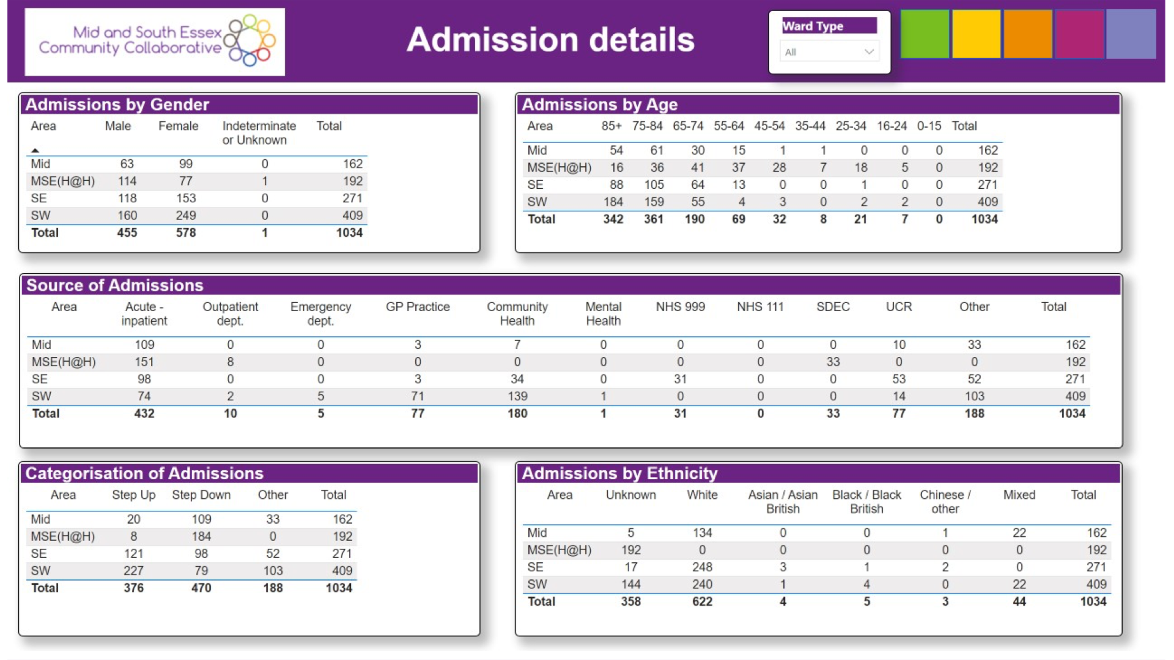
Who has accessed the Virtual Hospital?
To consider whether those admitted to the virtual wards are reflective of our population there is a need to note that 87% of all patients through virtual wards were over 65. Therefore, demographics of MSE population over 65 has been used in respect of a population comparator (detailed breakdown included in Appendix 3). 55% of over 65s in MSE are female. Hospital at Home has a broader range of ages and disproportionately more females within this service.

Overall, just 19% of the MSE population is over the age of 65. A higher proportion of which are female.
However, within virtual wards a disproportionately larger percentage of patients are over the age of 65. This is also seen in acute admissions and attendances in MSE NHS Foundation Trust.

Services are aimed at conditions which correlate with age in many cases, such as Frailty.
19% of the population in MSE are over 65, however, 87% of the admissions through virtual wards are for patients over 65.
10% of MSE are 65-74, Frailty services are only slightly above the population proportion, however, 65–74-year -olds make up 22% of admissions to H@H and 34% of admissions to Respiratory virtual wards.
Frailty proportions increase with age. 46% of admissions to the frailty wards are for patients over 85 (despite making up just 3% of the overall population).
In MSE, 98% of those over 65 are White.
Across the virtual wards, the largest proportion of patient are white, and a significant proportion are unknown (which is skewing some proportions).
MSE has a small population of just 0.3% Mixed, however, 4% of all admissions to virtual wards are for Mixed patients. This could mean a disproportionately larger proportion of Mixed ethnicity patients are being treated through the virtual wards, in particular respiratory.
Black and Black British patients are also disproportionately high in Frailty virtual wards compared to the over 65 population in MSE.
1.2% of the over 65 population in MSE is White but not British e.g., European. The patient demographics data for virtual wards does not split out British from European so it is not possible to determine proportions of patients who are White British from White European. Table four below provides a breakdown of ethnicity across the virtual wards.
Table 4.
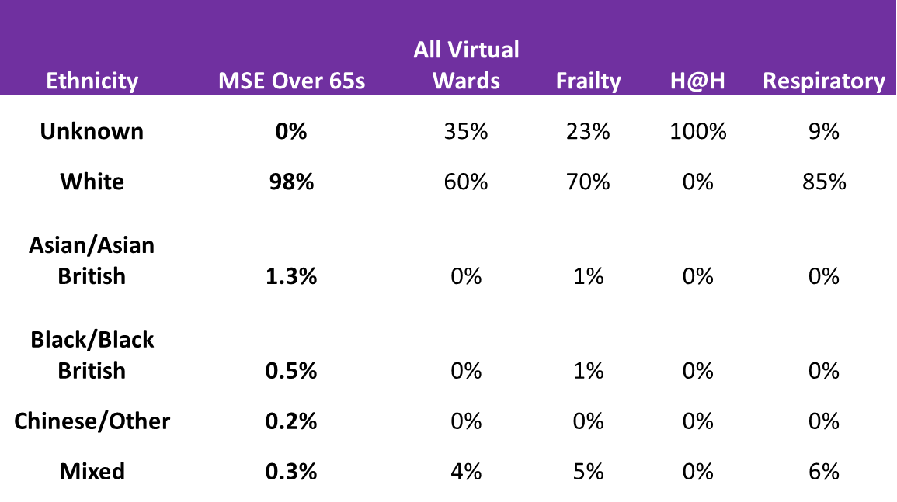
What is the impact on bed days in secondary care?

- Number of acute bed days saved as of July 2022 equates to 1,4163 (this does not include UCRT and Hospital@Home for April where the data is not available). Table five below outlines the bed days saved for the new virtual wards since April 2022 and the cost savings identified as a result.
- Cost savings to date for the two new virtual wards established in January 2022 equate to £1,333,480. The average saving per month for respiratory is £100,347 and £230,202 for frailty.
- The average length of stay is 12 days (Respiratory virtual ward), 16 days (Frailty Virtual Ward) and 35 days (Hospital@Home).
- The majority of patients are discharged to their usual residence (72.7%) as opposed to care homes at 3.6%.
Table 5.
Month | Virtual Ward Bed Days Saved |  |  |  | Avg. Virtual Ward bed cost |  | Avg. Acute bed Cost |  | Cost Saving |  | Avg. Virtual Ward Bed cost |  | Avg. Acute bed Cost | Cost Savings
Month | Respiratory |  | Frailty |  | Respiratory |  | Respiratory |  | Respiratory |  | Frailty |  | Frailty | Frailty
Month | (Bed Days) |  | (Bed Days) |  | (£) |  | (£) |  | (£) |  | (£) |  | (£) | (£)
Apr | 241 |  | 1,210 |  | £9,399 |  | £69,408 |  | £60,009 |  | £348,480 |  | £551,760 | £203,280
May | 224 |  | 1,329 |  | £8,736 |  | £64,512 |  | £55,776 |  | £382,752 |  | £606,024 | £223,272
Jun | 755 |  | 1,233 |  | £29,445 |  | £217,440 |  | £187,995 |  | £355,104 |  | £562,248 | £207,144
Jul | 392 |  | 1,709 |  | £15,288 |  | £112,896 |  | £97,608 |  | £492,192 |  | £779,304 | £287,112
Total | 1612 |  | 5,481 |  | £62,868 |  | £464,256 |  | £401,388 |  | £1,578,528 |  | £2,499,336 | £920,808
Avg Saving per month Respiratory |  |  |  |  |  |  |  |  | £100,347 |  | Frailty |  |  | £230,202
NB: Research undertaken by Newton states that we can increase utilisation by 65% on the virtual wards without additional investment, though implementing the evaluation findings

The calculation for working out bed days saved is the number of patients discharged from the virtual ward x the average length of stay for that ward. A study has been undertaken by NELFT to review the accuracy of these calculations with 56 patients and the outcome is consistent with the calculations applied. A more detailed piece of work is due to commence in relation to a detailed comparison of the virtual ward length of stay compared to the acute length of stay and ensuring the comparison is against a consistent cohort of patients.

How have we resourced the Virtua Hospital?
- The full number of staff required to operate the 60 bedded Frailty Virtual Ward across MSE is 122.4 WTEs. This has been resourced with 36.06 WTE members of existing staff, where services have been aligned to the virtual hospital model and 86.31 WTE of new staff.
- The Respiratory Virtual Ward requires 29.5 WTEs of which all are new appointments.
- A detailed breakdown of the staffing for the Frailty and Respiratory Virtual Wards is attached in Appendix 2.

How has technology been used to support delivery?
- Existing technology being utilised on the virtual wards is based on patient need upon clinical assessment and does not replace the need for clinical review and intervention. Following review of the findings further action will be taken to ensure that any barriers being faced in using this equipment are addressed. Further details of the technology utilised on our virtual wards is outlined in section 4.3 above. Telehealth technology is utilised in greater numbers on the respiratory virtual wards as these operate more remotely than the frailty virtual ward and Hospital@Home services.

Are we delivering great outcomes that improve the health and well-being of our patients?
Are we maximising independence?
- 23% of patients treated in a virtual ward achieved a more independent social care outcome

Are we minimising infection and preventing functional decline?
- Patients are up to five times less likely to acquire an infection when treated on a virtual ward compared to an acute setting.
Are we minimising readmissions?
- Up to 2.5 times fewer patients treated on a virtual ward are readmitted to frailty beds than the national benchmark.

7. Limitations

7.1 Key Challenges

To undertake this evaluation within the timeframes available and to the extent in which it has been done was possible due to the external support provided by Newton Europe and Deloitte teams. This is due to the number of site and home visits required to obtain patient and staff feedback on the scale required, across a large geographical area.

Obtaining data to support this evaluation has not been identified as an issue, the evaluation has benefited from the exceptional Business Intelligence and Insights staff working across MSE.

Staffing breakdowns and numbers reflect the two new virtual wards and does not include the existing virtual wards (Hospital@Home and UCRT).

Finally, had there been more time areas identified through undertaking this evaluation would have been explored in greater depth.

7.2 Plans for future evaluation

There has not been a focus within this evaluation on return on investment, to understand the full costs of setting up a virtual ward, and the subsequent financial return. A health economic evaluation is needed to understand this aspect and MSE ICS.

A more in-depth study is required to provide assurance that estimated bed day savings compare to the correct cohort of patients in respect of hospital length of stay.

Ongoing monitoring and evaluation of activity and performance is to be undertaken by the Virtual Hospital Programme Board utilising the performance measures developed.

8. conclusion
The existing technology enabled virtual wards in MSE to deliver improved outcomes compared to traditional pathways, strengthening the case to improve utilisation

- We can improve utilisation by up to 65% through operational improvements over the next 12-18 months, delivering improved outcomes for over 1,350 people per year

- This will require a joined-up end-end transformation programme that includes

  - Improved referral rates – with opportunity to increase total referrals by 173% by building knowledge and confidence of referrers
  - Capacity improvements – with an opportunity to increase capacity by 65% by focusing on discharge delays, staff scheduling and ways of working
  - Consideration of key enablers – including culture, supporting data, tools & technology, performance visibility & governance, clinical leadership, aligned pathways, practice and process, and capability of key staff

- Utilisation could be further increased through a systematic approach to evaluation and commissioning that enables:

  - Increased capacity for current virtual wards that are still capacity constrained following delivery of operational improvement
  - Expanded capability of the current virtual wards to allow more patients to be treated
  - Commissioning new virtual wards to allow additional patient cohorts to be treated

- Further information needs to be obtained on a larger control group and over a longer period, to fully understand the impact of the virtual hospital model.

9. Recommendations
This evaluation has exposed further questions that MSE ICS needs to understand in greater depth to continue to build on the virtual hospital model across our system and the move towards an integrated approach across our system. To support this dedicated workstreams need to be established with wide ranging representation from across MSE ICS.

There is a need to ensure that any expansion regarding the use of virtual wards goes hand-in-hand with consideration and support for staff.

There is evidence of the need for a targeted training and change management approach to improve referral rates. This will require a more detailed assessment of where referring staff fall on the change journey.

We need to better understand staff awareness, understanding, and knowledge of why, when and how to refer to virtual wards, and to better understand staff decision making behaviours and confidence in our virtual wards. This will allow the right content and approach to be designed, tested, and delivered.

Considering learnings from the Connect UCRT project, which drove a 70% increase in accepted referrals per week as part of the Connect programme, we know that the following enablers will also be required to support increased referrals:

- Clinical leadership to ensure appropriate service design (practice, pathways and process and capabilities) that provides effectively for target cohorts, and alignment between acute and community teams.
- Creation of a single source of truth to provide an objective view of both referral rates and accepted referral rates by service and source, and to provide a view of key challenges and their root causes.
- Clear accountability for referral rates throughout the system – including in the Acute, UCRT and Virtual Ward teams.
- Effective system governance to ensure system alignment of performance and key challenges and to allow for appropriate actions and escalations to be agreed and monitored.

Considering learnings from the Connect Community Pathways project, which drove a 45% reduction in patient discharge delays in MSE community hospitals, we know that a joined-up approach is needed to systematically tackle discharge delays, including:

- Creation of a single source of truth to provide a live view of length of stay by patient, next steps to facilitate discharge, and discharge blockers.
- Establishment of effective “improvement cycle” governance where a Multi-Disciplinary Team regularly review discharge next steps and challenges and agree and progress SMART actions to facilitate timelier discharges.
- Clear accountability for length of stay and discharge delays within the system
- Consideration of ringfenced capacity in Social Care and / or bridging to support virtual ward discharges

Considering learnings from other programmes focussed on improving capacity in health and care systems, the following steps are also recommended to unlock remaining capacity opportunities:

- Improving early understanding of expected staff absence to allow for scheduling decisions to be made sooner
- Implement appropriate digital tooling to enable the efficient distribution of staff over-time that matches anticipated match service demand, and gives visibility of annual leave and sickness
- Ensure there is appropriate matched weekend capacity in the acute to support increased assessments and referrals
- Address staff ways of working to enable staff to spend more time actively treating patients, with continued focus on travel planning (e.g., through route planning software) and reduced administrative burden (e.g., through implementation of Dragon Dictate and Bridgid)
- Effective system governance, including accountability and embedding of key operational metrics to drive improvement work

There is a need to explore the cost-benefit of improving the capability of current virtual wards - particularly focusing on improving:
  - Frailty Virtual Ward capability to provide IV antibiotics
  - Respiratory Virtual Ward capability to provide IV antibiotics alongside oxygen
  - Hospital @ Home capability to take someone home with a naso-gastric feeding tube
  - Develop a strategic approach to evaluate and commission new virtual wards, through the following stages:
  - Identify opportunity areas and develop understanding of potential benefit
  - Prioritise cohorts for virtual ward development
  - Develop an appropriate operating model by considering capacity and demand, pathways, practice and process, workforce, data and digital tooling, leadership, culture, and governance
  - Starting small, test and iterate the designed operating model for the cohort of choice
  - Roll out the successful virtual ward across MSE
  - Repeat steps 3-5 for all prioritised cohorts

Through this approach:
  - Continue with the scoping and commissioning of the planned Cardiac Virtual Ward
  - Scope other potential Virtual Wards: Gynaecology, Orthopaedic and Stroke.

Next Steps

To continue to shape a transformation programme, developing workstreams and enablers, key performance indicators, identifying appropriate leads / teams, and phasing.

To hold design sessions with key colleagues to develop an outline structure and plan:
  - Wider system engagement summit sessions to review and refine planned scope
  - We need steer and input from clinical and operational colleagues from throughout the system – this will ensure that we design a programme that is suitably ambitious, realistic, and aligned.

To continue to develop expected financial benefits from delivering improvement scope.

10. Appendices
Appendix | Document
Appendix One – Full Diagnostic Summary Provided by Newton Europe

Appendix Two – Workforce Breakdown for Respiratory and Frailty Virtual Wards

Appendix Three – Virtual Wards Dashboard, including population comparators

Appendix Four – Virtual Ward Operating Costs

Reference: NHSEI Tour de East How to get involved booklet

